Topic: ENGR7761 Image processing

Assignment 2:

PRACTICAL DEVELOPMENT

**PROJECT 02-02: Reducing the Number of Intensity levels in an image**

SUBMITTED BY:

Jasmeen Chahal

Chah0035

2187269

Due date: 1st June 2020

Date handed in: 4th June 2020

Project’s GIT HUB page: <https://github.com/jasmeen0035/chah0035_project>

**Abstract**

This report is addressing the problem of developing the algorithm for printing the gray-scale images based on intensity resolution and compare the result with other reports. The objective is to understand how the number of intensity levels affects image quality. There are so many problems regarding the image processing because of high or low intensity in the image like in medicalimages. So, we need to reduce or increase the intensity of the pixels. This will help to correct the diagnosis of disease. Intensity resolution denotes the smallest discernible change in intensity level. Based on the hardware considerations, the number of intensity levels generally an integer power of 2. The most common are 8 and 16 bits. Sometimes one can find that the system can digitize the intensity levels of an image using 10 or 2 bits, but still not common. I have compared the results and find that there are many changes and information loss in the results.

For the reduction in the intensity of an image, I apply different useful techniques as we know that in some images the texture of an image is the most important component, like in medical images. Due to high intensity, sometimes there is a reflection in an image that results in an inappropriate description of an image. So, I can normalize the image intensity by the powers of 2.

**Introduction**

**Intensity Reduction Method:** - As per the intensity of the image is considered, it is one of the important components of an image. As I discussed earlier the intensity will sometimes create a distraction from the actual results. So we need to reduce the intensity value of pixels for a clearer image to get appropriate results. The intensity value for each pixel is a single value for a gray level image or three values for a color image.

This method is used in medical sciences, forensics, medical imaging systems like x-ray imaging systems.

The objective of the example is to reduce the number of intensities of the image from 256 to 2 in integer power of 2 while leaving the image resolution at a fixed dpi.

**Technical Discussion**: -

I have used the intensity reduction method and analyze results as mentioned in the report. An alternative approach to getting intensity value from a single image is the multispectral imaging technique, with which more than one image of the same product at the same location can be gained from different wavelengths.

In this program, we have imported many pre-defined libraries which are most beneficial libraries like NumPy for mathematical operation, OpenCV for images, matplotlib for plotting purpose, etc.

**Python**: This is a general-purpose programming language.

**OpenCV**: OpenCV is an open-source. OpenCV supports a wide range of programming languages such as C++ and Python and available on different platforms including Windows, Linux, etc.

**Numpy**: It is the fundamental package for scientific computing with Python. This is a highly optimized library for numerical operations.

Many other libraries such as Matplotlib which supports NumPy can be used with this.

There are so many functions which are implemented in this code is like: -

* cv2.imread(): - for reading the image.
* Input function: - for taking the user input.
* Matplotlib.pyplot.imshow(): - for display the image

Here, intensity factor is the 2^k i.e. from which level to which level we reduce the intensity level and here k is the intensity factor.

Here, I divide the entire range into the desired number of parts (levels) with size as step and used ceil function to restrict the result to the upper bounds. This is given by: -

Intensity factor = 256 / intensity level.

Then, we get a new intensity image by: -

Np. floor (np. double (image) / 256 * Intensity level) * Intensity factor.

This will give the new image of the desired intensity after reduction which will help in examining the correct results from the image.

In this, an algorithm to reduce the number of intensity values in an image is as follows: -

* Firstly, we will take an image.
* Then, we convert it into float and after that normalize it in the interval [0, 1].
* Multiply this with the number of desired quantization steps like 128, 64, 32, 16, 8, etc.
* Then round off (floor) the values and then again convert it into unit8.

Perform the same procedure for the intensity reduction to all bits.

**Result**

The result in example gives the effects produced by image quality by varying intensity reduction. The previous theories used the images of the face of a person and gives different results. Here, I have used the image of a skull and depicts the variations. As we have seen that as we go down to the intensity level the picture gets more dullness. This means that the information gets lost. Here, the original image of the skull in Fig.1 and Fig.2 to 8 were obtained by reducing the intensity level of 128, 64, 32, 16, 8, 4, 2 respectively.

Original image Intensity level when 2^k:128

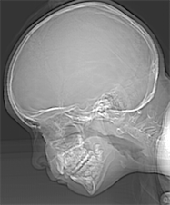 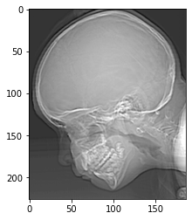

Fig.1 Original image Fig.2 Gray level $2^{7}$

Intensity level when 2^k:64 Intensity level when 2^k:32

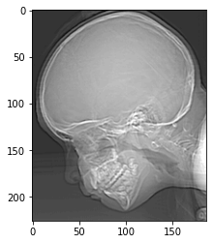 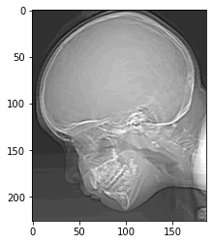

Fig.3 Gray level $2^{6}$ Fig.4 Gray level $2^{5}$

Intensity level when 2^k:16 Intensity level when 2^k:8

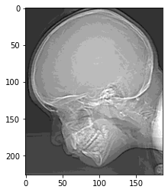 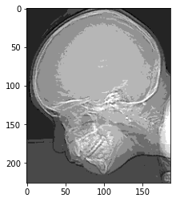

Fig.5 Gray level $2^{4}$ Fig.6 Gray level $2^{3}$

Intensity level when 2^k:4 Intensity level when 2^k:2

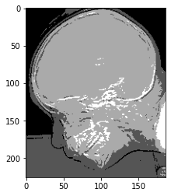 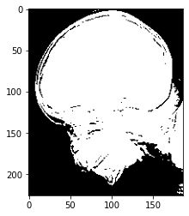

Fig.7 Gray level $2^{2}$ Fig.8 Gray level $2^{1}$

**Conclusion**

We were able to successfully plot the intensity levels and the results were found by running the code. This shows the robustness of the code and dynamically implemented functions.

**References**

* Gonzalez, R. C., & Woods, R. E. (2017). *Digital image processing, global edition*. Retrieved from <https://ebookcentral-proquest-com.ezproxy.flinders.edu.au>
* Kociołek, M., Strzelecki, M., & Obuchowicz, R. (2020). Does image normalization and intensity resolution impact texture classification? *Computerized Medical Imaging and Graphics,* *81*, 101716.
* [https://www-sciencedirect-com.ezproxy.flinders.edu.au/topics/computer science/intensity-value](https://www-sciencedirect-com.ezproxy.flinders.edu.au/topics/computer%20science/intensity-value).